**INSTRUCTIONS FOR RUNNING PYTHON FILE**

1. Open a folder and save the “final.py” file in it. Inside this folder, create another two folders; one for web scraping the HTML document and another for storing the article texts and headings.
2. Run the python file and it will ask for URL. Enter the URL from the Output Data Structure.xlsx. It will then ask for URL_ID. Enter the URL_ID from the same Excel Document.
3. Now it will ask where to store the text file which will the article contents and the headings. Write the name of folder followed by forward slash (/).
4. Next it will ask for the HTML document path for web scraping. Write the name of the folder followed by forward slash (/).

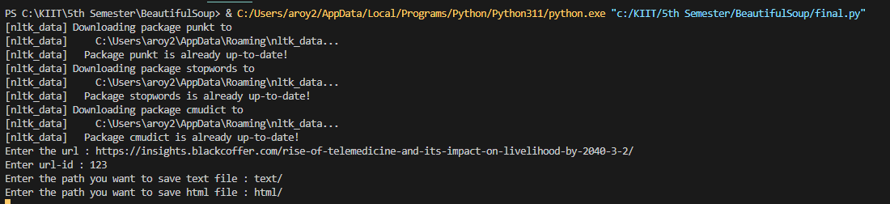

Above screenshot is attached for reference.